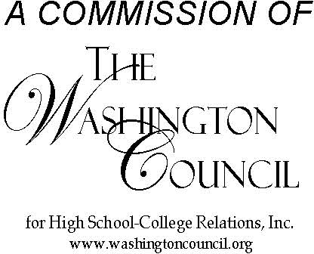

INTERCOLLEGE RELATIONS COMMISSION
A Commission of the Washington Council for High School-College Relations
https://www.wa-council.org/icrc/
Spring 2022 Meeting Agenda
Thursday, April 14, 2022 9:00 a.m. – 12:00 p.m.

Join Zoom Meeting from PC, Mac, Linux, iOS, or Android:
https://olympic.zoom.us/j/91425783234
Notes: Zoom account authentication may be required to join this meeting. Please also update your Zoom display name to include your institution consider wearing school logo or using it as a Zoom background. There will be a Zoom waiting room for attendees.

8:30 a.m. – Zoom open for general meeting/social chat/ introductions

9:00-9:20 – ICRC Meeting Opening Session
•Call to Order – Kirsten Clawson
•Approval of Winter Minutes– Kirsten Clawson
•Treasurer’s Report – Rose Spodobalski-Brower
•OAR Report- Beccie Seaman

9:20- 9:50 – Agency Discussion Q&A
•Independent Colleges of Washington (ICW) – Shea Hamilton
•Council of Presidents (COP) – Julie Garver
•Joint Transfer Council (JTC) – Julie Garver
•State Board for Community and Technical Colleges (SBCTC): Valery Sundby

9:50-10:00 – Break

10:00-10:30 ICRC Update on AA-DTA and Open Discussion
Unpacking the AA
Possible Topics (from new member meeting)

10:30-11:30 – Community College Research Initiatives (CCRI) Facilitated Discussion with Dr. Lia Wetzstein

11:30-11:50— Executive Board and OAR Voting of Members

11:50-12:00— Wrap Up

12:00 – Adjournment

Tentative 2022-2023 Meeting Dates:
Fall October 13-14, 2022
Winter (Zoom) February 9, 2023
Spring April 13-14, 2023

